


SUMMER TRAINING REPORT

राष्ट्र ीय इलेक्ट्र ॉनिकी एवं सूनKा प्रौद्योनिकी संस्थान गोरखपुर
National Institute of Electronics & Information Technology Gorakhpur Duration: 08.08.2024 – 11.09.2024

Submitted to : Submitted by :
Mr. VINAY KANNAUJIYA ADITYA MAURYA
HOD, Department of Computer E22480735500038
Science &Engineering Computer Science & Engineering
Sign………………………………

Session - 2024

Mahamaya IT Polytechnic, Maharajganj
(Govt. Polytechnic Affiliated to Board of Technical Education Uttar Pradesh) District Jail Road, Dhanewa-Dhanei, Maharajganj, U.P - 273303

1 | P a g e


PREFACE
This report document the work done during the
summer training at National Institute of Electronics & Information Technology, Gorakhpur under the guidance of Ms. Sheerie khan ma’am. The report first shall give the overview of performed during the period of training.
I have tried my best to keep the report simple yet
technically correct. I hope I succeed in my attempt.

ADITYA MAURYA

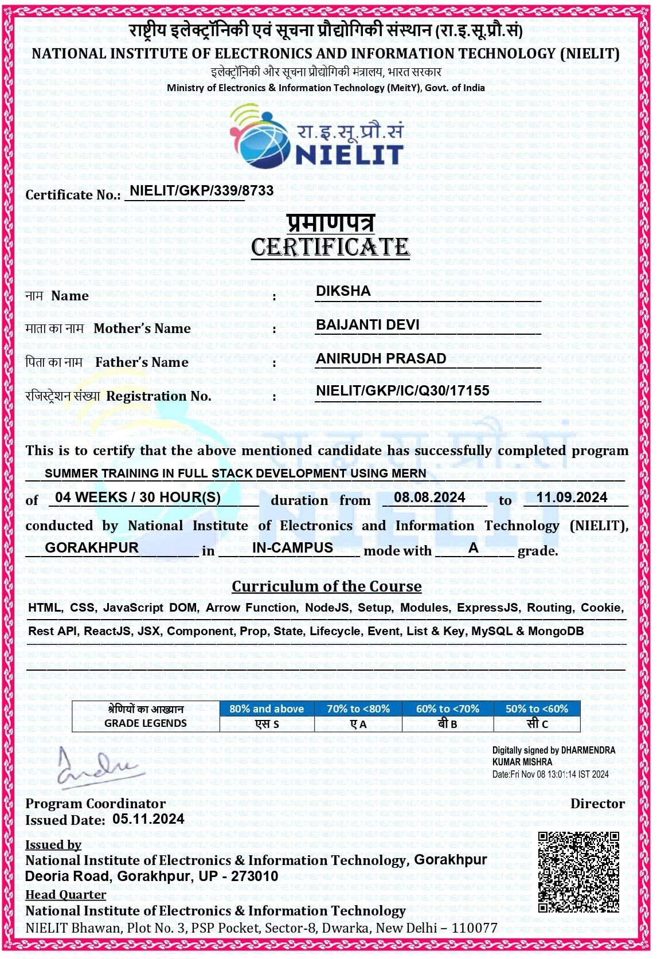
2 | P a g e

CERTIFICATE
Figure 1

3 | P a g e

PROFILE OF THE ORGANISATION

About to NIELIT Centre :
- NIELIT, Gorakhpur Centre was established as Centre for Electronic Design & Technology of India (CEDTI) in June, 1989.
- It is an Autonomous Scientific Society under the administrative control of Ministry of Electronics and Information Technology, Govt. of India.
- NIELIT Gorakhpur, is a Premier institution for Education, Training, Research & Design and Consultancy in IT and Electronics.
- It conducts course for, Embedded Systems (Internet of Things), VLSI, PCB Manufacturing, MATLAB, Instrumentation etc.

Course Offered by NIELIT:
- Over the last two decades, NIELIT has acquired very good expertise in IT training, through its wide repertoire of causes, ranging from ‘O’ Level (Foundation), ‘A’ Level (Advance
Diploma), ‘B’ Level (MCA equivalent), ‘C’ Level (M-Tech level), IT literacy courses such as CCC (Course on Computer Concept),
BCC (Basic Computer Course) and other such long term and short term course in the non formal sector like courses on Information Security, ITeS-BPO(Customer Care/Banking), Computer
Hardware
Maintenance (CHM-O/A level), Bio-Informatics(BI-O/A/B level), ESDM etc., besides, high end courses offered by NIELIT Centers at Post-Graduate level (M.Tech) in Electronics Design & Technology, Embedded Systems etc.
- Which are not normally offered by Universities/Institutions in the formal sector, in association with the respective state Universities.

4 | P a g e

TABLE OF CONTENTS

Sr. No. | CONTENT | PAGE  NO.
1. | INTRODUCTION | 06
2. | MERN & ITS COMPONENTS | 07-09
3. | HTML, CSS, JAVASCRIPT | 10-12
4. | A MERN PROJECT PLANNING | 13
5. | PROJECT TITLE | 14-16

5 | P a g e


INTRODUCTION

Full-Stack Web Development using MERN refers to building web applications using the MERN stack, which consists of
MongoDB, Express.js, React, and Node.js. The combination of these technologies allows developers to create complete web applications, from the frontend (user interface) to the
backend (database and server).

ADVANTAGE:
The MERN stack offers significant advantages in terms of speed, scalability, and flexibility. It allows for full-stack
development using JavaScript across both the client-side and server-side, providing a unified and efficient development
experience. The React component allows for rich, interactive user interfaces, while Node.js, Express, and MongoDB offer a powerful backend capable of handling large amounts of data and real-time communication. This makes MERN an excellent choice for building modern web applications, from
prototypes to full-scale production systems.

6 | P a g e

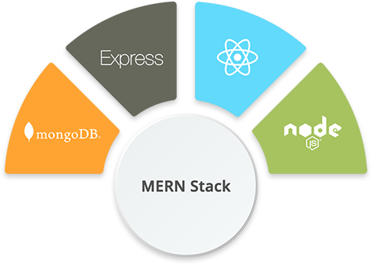
MERN & ITS COMPONENTS
MERN Stack is a compilation of four different technologies that work together to develop Dynamic Web App and
Websites.
It is a contraction for four different technologies, as mentioned below:
- M - MongoDB
- E - Express.js
- R – ReactJS
- N - Node.js

MongoDB
  - Type: NoSQL Database
  - Role: Backend Database
  - Function: MongoDB is a document-oriented NoSQL database that stores data in a flexible, JSON-like format called BSON (Binary JSON). It is used to store data for

7 | P a g e

the application and enables fast querying and scalability.

Key Features:
    - Stores data as collections of documents.
    - Schema-less, meaning it allows for flexible data storage.
    - Can handle large volumes of unstructured data.

Express.js
  - Type: Web Framework
  - Role: Backend Server Framework
  - Function: Express.js is a minimal and flexible Node.js web application framework. It provides a set of
features to build web applications and APIs, such as routing, middleware support, and session management.

Key Features:
    - Simplifies HTTP request handling. o Handles RESTful APIs and routes. o Middleware support for error handling, authentication, etc.

React
  - Type: Frontend Library
  - Role: User Interface (UI)
  - Function: React is a JavaScript library used to build user interfaces, especially single-page applications

8 | P a g e

(SPAs). It allows the creation of reusable UI
components that update efficiently in response to data changes.

Key Features:
    - Component-based architecture. o Virtual DOM for efficient rendering. o One-way data flow for better maintainability. o Integrates well with other libraries and
frameworks (like Redux for state management).

Node.js
  - Type: JavaScript Runtime Environment
  - Role: Backend Server Runtime
  - Function: Node.js is a runtime environment that allows JavaScript to be used on the server side. It is built on Chrome’s V8 engine and uses non-blocking, event-driven architecture, making it suitable for I/Oheavy operations like handling HTTP requests.

Key Features:
    - Asynchronous and event-driven. o High scalability for handling numerous
connections simultaneously. o NPM (Node Package Manager) for easy access to a wide range of libraries and tools.

9 | P a g e

HTML, CSS, JAVASCRIPT

HTML (Hyper Text Markup Language)
Purpose: HTML is used to create and structure the content on the web. It defines the layout and structure of a webpage using tags and elements. Key Concepts:
  - Elements: Basic building blocks of HTML (e.g., <div>, <p>,
<h1>, <a>).
  - Attributes: Provide additional information about elements (e.g., href, src, alt).
  - Tags: HTML elements are defined by opening <tag> and closing </tag> tags (e.g., <h1>Hello World</h1>).
  - Nesting: HTML elements can be nested inside each other (e.g., <ul><li><a href="#">Link</a></li></ul>).

Common Tags:
  - Headings: <h1> to <h6> (for headings of different sizes).
  - Paragraph: <p> (for text).
  - Links: <a href="url">Link text</a> (for navigation).
  - Images: <img src="image.jpg" alt="description"> (for images).

Lists:
    - Ordered: <ol><li>Item</li></ol> o
Unordered: <ul><li>Item</li></ul>
  - Forms: <form>, <input>, <button>, etc. (for user input).
  - Tables: <table>, <tr>, <td>, <th> (for displaying data).

CSS (Cascading Style Sheets)
Purpose: CSS is used to style and layout HTML elements. It controls the look and feel of the webpage, such as colors, fonts, spacing, and positioning. Key Concepts:
  - Selectors: Target HTML elements to apply styles (e.g., p, #id,
.class).
  - Properties and Values: Define the styles applied to elements (e.g., color: red;, font-size: 16px;).

10 | P a g e

- Box Model: All elements on a webpage are treated as boxes with padding, borders, margins, and content. Common CSS Properties:
- Color & Background: o color: Sets text color.
o background-color: Sets background color.

Text Styling:
  - font-size: Sets the font size. o font-family: Specifies the font family.
  - text-align: Aligns text (left, right, center).

Box Model:
  - margin: Space outside the element. o padding: Space inside the element, around content.
  - border: Border surrounding the element.

Positioning:
o position: Defines the positioning method (static, relative, absolute, fixed, sticky). o top, right, bottom, left: Used with positioning to place elements.

Display & Visibility:
o display: Controls the layout of elements (block, inline, flex, grid). o visibility: Controls whether an element is visible or hidden.
- Flexbox & Grid: Layout systems used for responsive designs.
  - Flexbox: display: flex; aligns items along a row or column. o Grid: display: grid; defines a grid-based layout.

JavaScript (JS)
Purpose: JavaScript is a programming language used to add interactivity to webpages. It allows dynamic content updates, animations, form validation, and interaction with the server.

Key Concepts:
- Variables: Store values for use later. o let, const, var (to declare variables). o Example: let name = "John";.

11 | P a g e

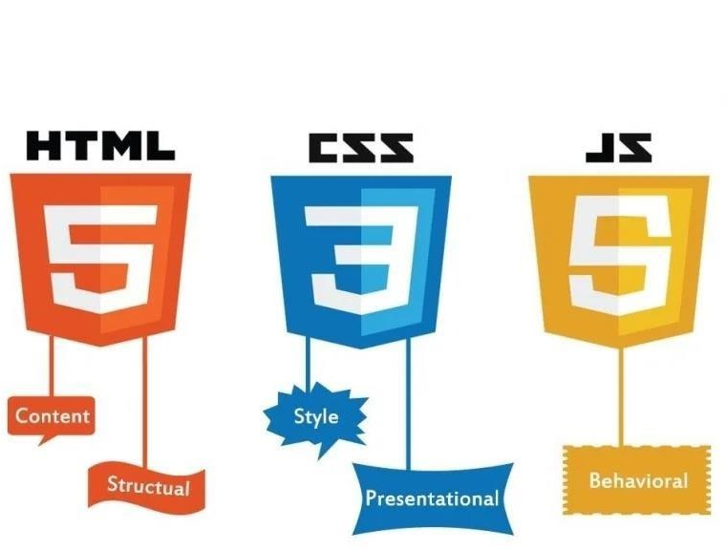
- Data Types: Types of data in JavaScript.
  - Primitive: string, number, boolean, null, undefined, symbol.
  - Complex: object, array, function. • Functions: Reusable blocks of code.
- Events: Allow interaction with the page (e.g., clicks, key presses). o Example: document.getElementById("btn").addEventListener("click
", function() { alert("Clicked!"); });
- Conditional Statements: Control the flow of code based on conditions. o if, else, switch, ternary operator.

- Loops: Execute a block of code repeatedly. o for, while, forEach, map. • Objects: Used to store collections of data.

- HTML: Structures the content of a webpage with elements and attributes.
- CSS: Styles and layouts the HTML content, making it visually appealing.
- JavaScript: Adds interactivity, dynamic content, and behavior to the webpage.

12 | P a g e

A MERN PROJECT PLANNING
- Front End
  - Knowledge
    - ReactJS
    - HTML
    - CSS iv. JavaScript technologies like: Events, Promise etc.
v. AXIOS: It is a REST API that makes XMLHTTP Requests from browsers very easy and short.

  - Required Tools
    - ReactJS:
npx create-react-app [name of the app]

    - React Bootstrap:A React library to use Bootstrap classes.
npm i bootstrap@5.1.0

    - Formik: A React library to create and validate complicated forms in the browser.
npm i formik

    - AXIOS:
npm i axios

- Backend
- Yup: A React Library for making complex form validations easy and quick.
npm i yup

  - Knowledge and Tools:
    - Express JS:
npm install express

    - Mongoose: A Node package to used MongoDB databases.
npm install mongoose

    - APIs
    - Body Parser: It’s a middleware that parses the entire body of a request object.

13 | P a g e

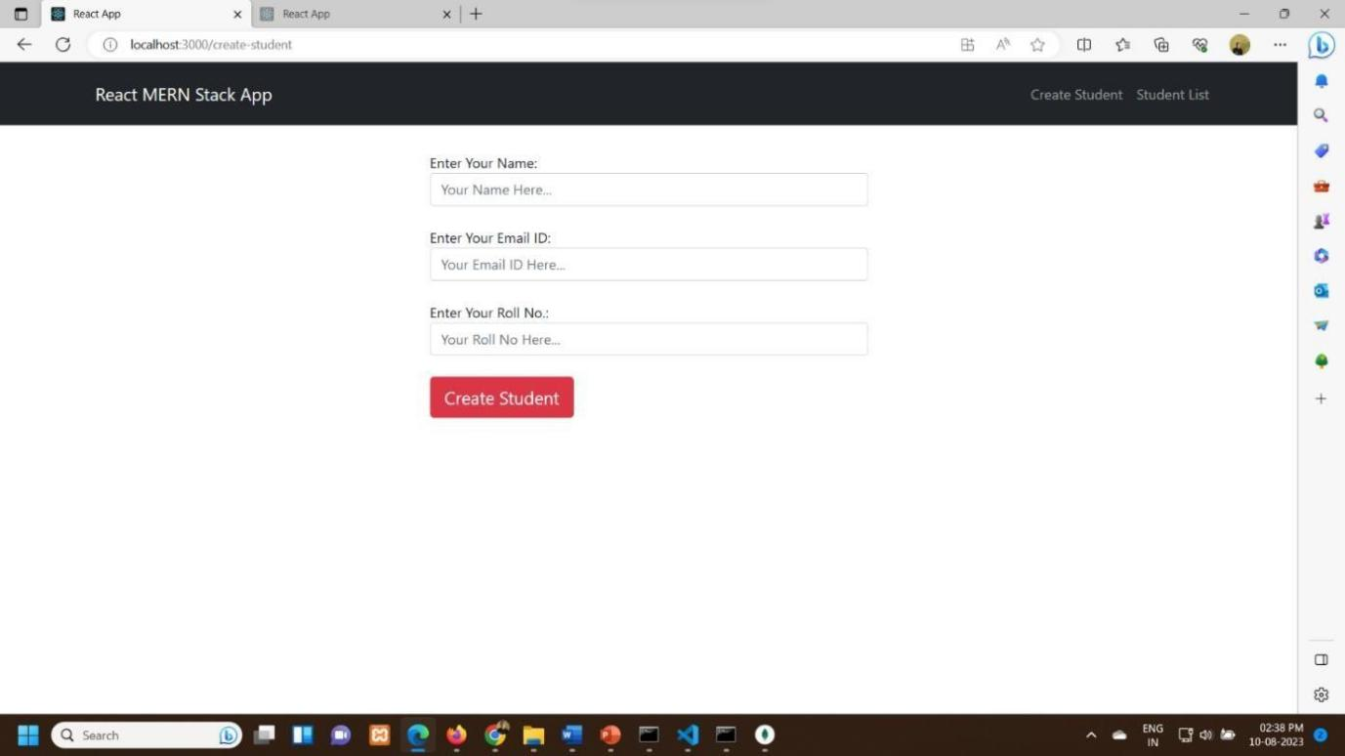
npm install body-parser

    - CORS: It’s a middleware in Express that works for cross-origin Resource Sharing in browsers.
npm install cors

PROJECT TITLE

Student Directory
This is a simple MERN project to CREATE, READ, UPDATE and DELETE student records from database. Technologies used:
- Front End: React JS
- Back End: Express JS
- Database: MongoDB
- Runtime Environment: Node JS
Screenshot: Create Student

14 | P a g e

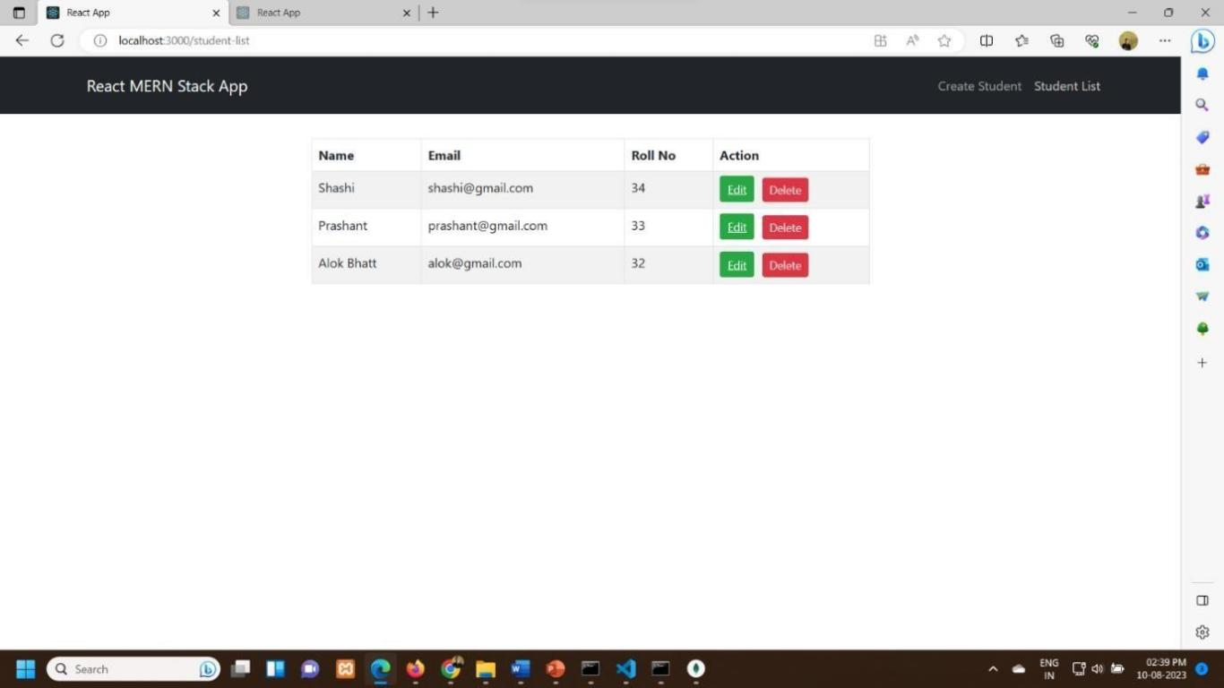
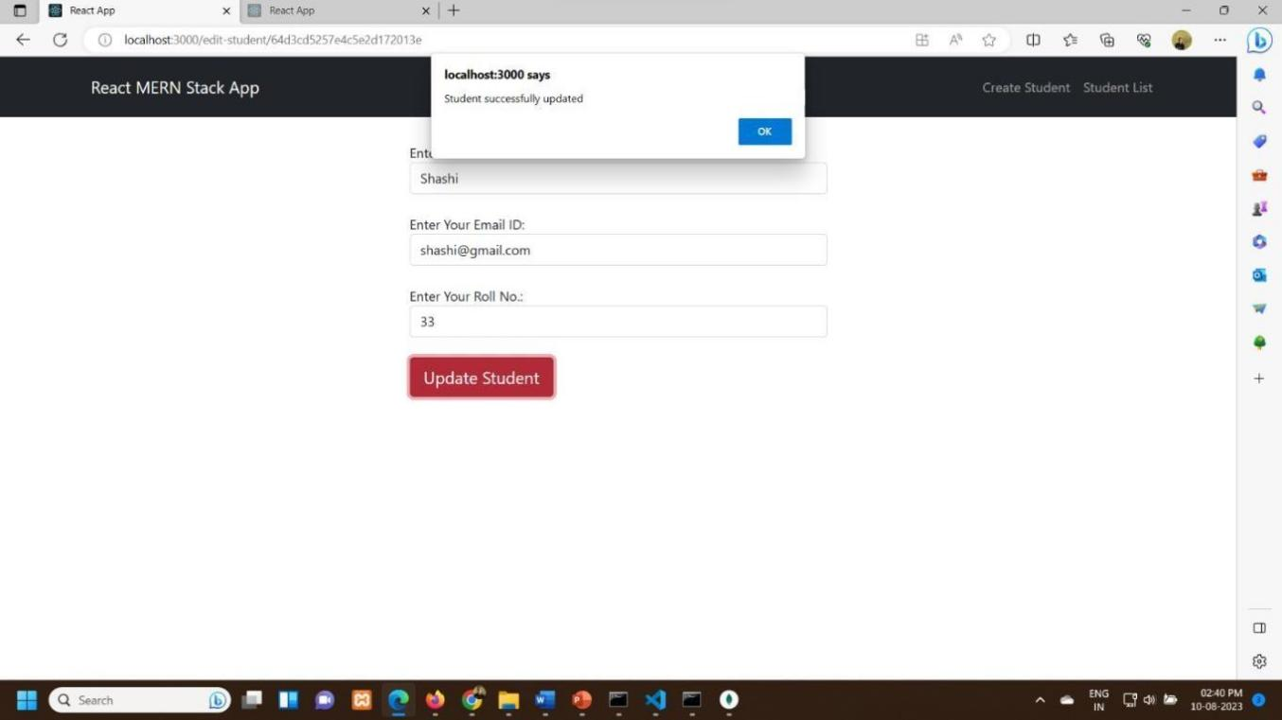
Screenshot: Student List

Screenshot: Edit Students

The Directory Structure:

15 | P a g e

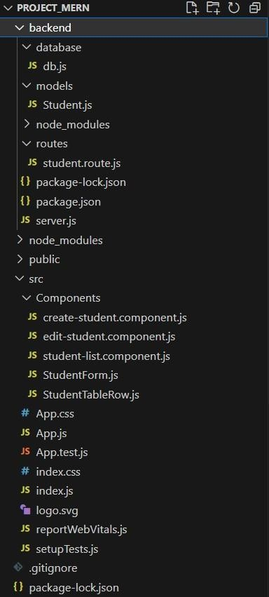
File to connect to the database File to create student schema
File to hold all routes for different APIs

File to handle actual backend and all middleware

Files to hold all the components

File to handle actual frontend File to render app component

16 | P a g e






CREATED BY :
ADITYA MAURYA
EN.NO : E22480735500038

17 | P a g e

